# System Architecture

## Backend

This application is based on the Spring Boot framework, combined with MyBatis-Plus for data persistence operations, and utilizes Spring Security for security control.

## Frontend

The application employs the Vue frontend framework, which is responsible for user interface display and interaction, communicating with the backend through RESTful APIs.

## Database

The application uses a MySQL relational database and a Redis caching database.

# Business Function Module Description

## Backend

### The environment configuration files are as follows, corresponding to the Development Environment, Testing Environment, and Production Environment. Adjustments should be made according to actual conditions.

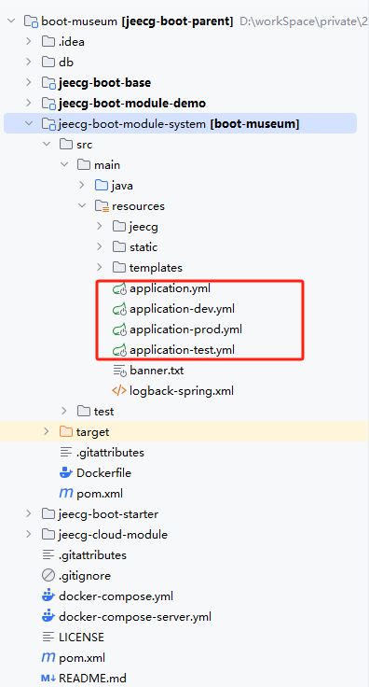

### The business function code is located in the src/main/java/org/jeecg/modules/show package:

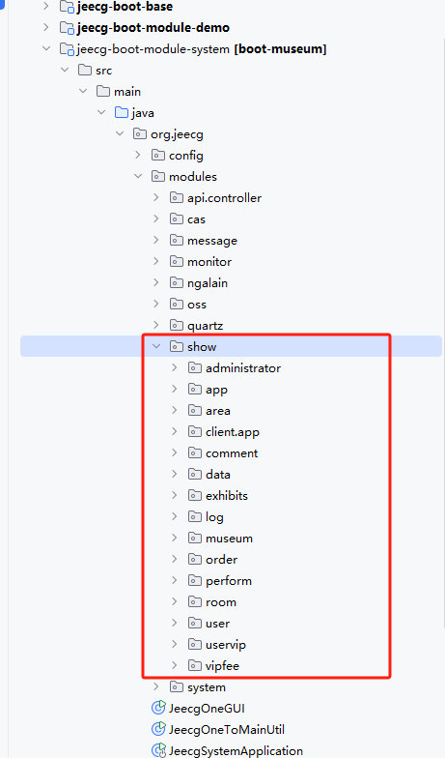

### APP Interface Class: src/main/java/org/jeecg/modules/show/client/app/AppController.java

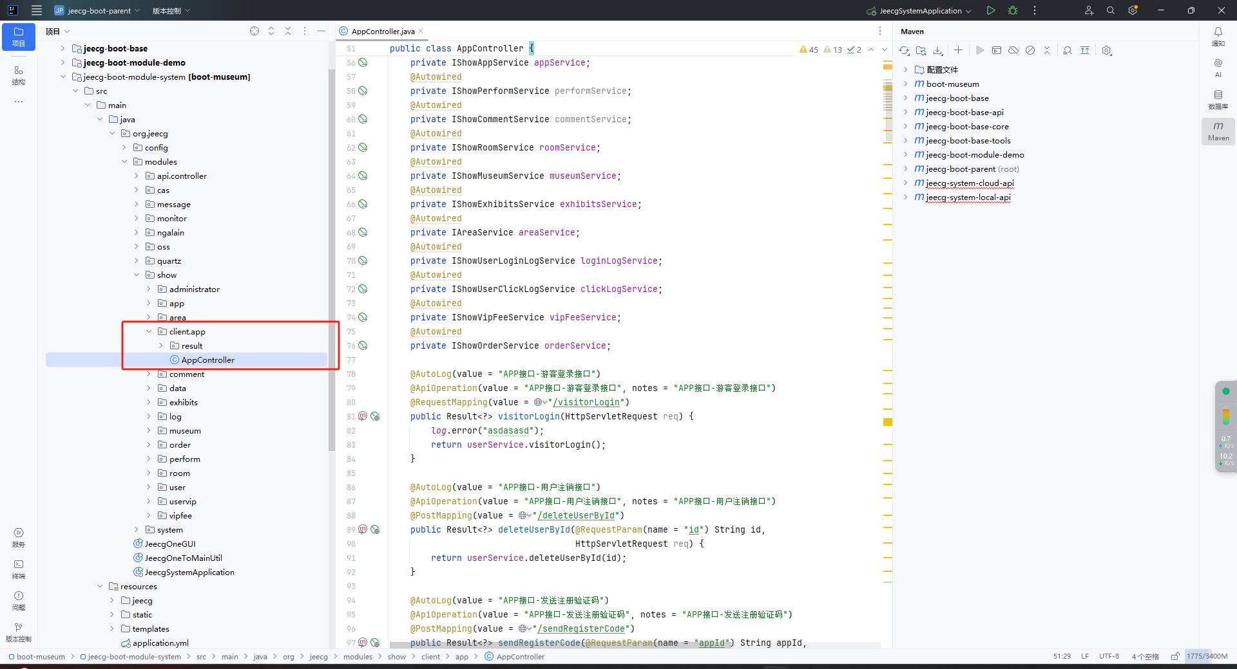

## Frontend

### The environment configuration files are as follows, corresponding to the Development Environment, Testing Environment, and Production Environment. Adjustments should be made according to actual conditions.

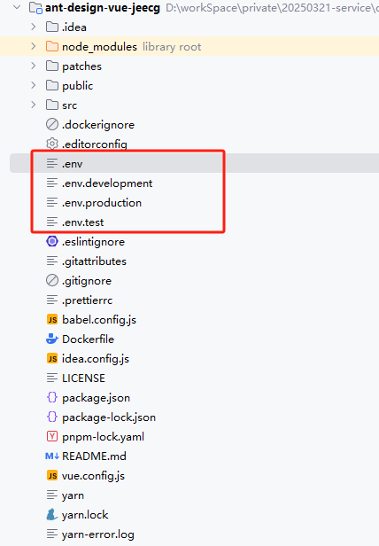

### The location of the business code is illustrated in the figure below:

# Setting Up the Development Environment

First, prepare to install the following software packages:  
jdk：1.8  
apache-maven：apache-maven-3.5.0

Mysql：5.7

Redis：3.2.100

Nodejs：16.20.2

## Backend

### Initialize the database.

Create the database, then execute the SQL script: boot-museum-data.sql.

### Install Maven dependencies.

### Modify the MySQL and Redis configurations in the development configuration file.

### Start the project using the main class: src/main/java/org/jeecg/JeecgSystemApplication.java.

## Frontend

### Install Yarn by executing npm install -g yarn; after installation, run yarn --version to verify.

### Navigate to the project root directory and execute yarn install to install the dependencies.

### Configure the development environment settings.

### Run yarn run serve to operate in development mode.